SIR SYED UNIVERSITY OF ENGINEERING & TECHNOLOGY
COMPUTER SCIENCE & INFORMATION TECHNOLOGY DEPARTMENT

Fall 2024
Probability & Statistics
Assignment # 2
Semester: 5th Batch: 2022F
Student’s Name: Muhammad Faisal
Roll#: 2022F-BCS-152 Section: C
Total Marks:04 Marks Obtained:
CLO # | Course Learning Outcomes (CLOs) | PLO Mapping | Bloom’s Taxonomy
CLO 2 | Use the concepts of descriptive statistics in problem solving. | PLO_2  (Knowledge for Computing Problem) | C3  (Applying)

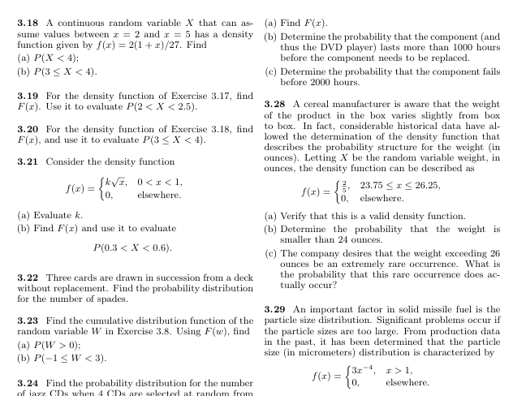
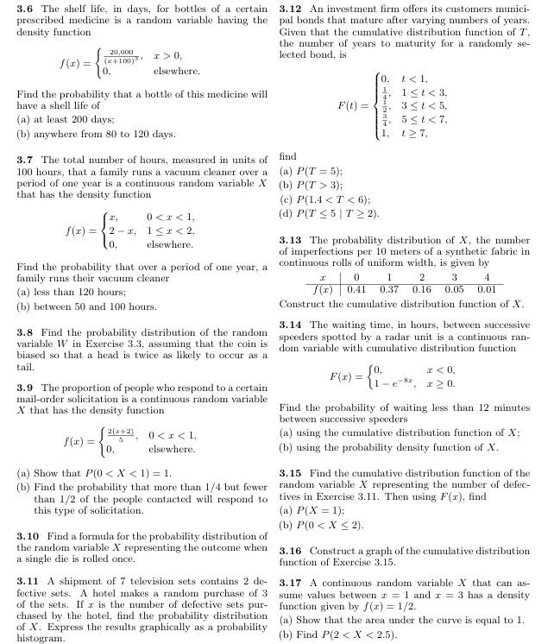

Problem 3.6
Given:
- Density function for the shelf life of medicine:
- f(x) = 20,000 / (x + 1000)^2, x > 0
a) Find the probability that a bottle of this medicine will have a shelf life of at least 200 days.
- To find P(X ≥ 200), we integrate the density function from 200 to infinity:
- P(X ≥ 200) = ∫(20,000 / (x + 1000)^2) dx from 200 to ∞
  - This integral evaluates to:
  - [(-20,000 / (x + 1000))] from 200 to ∞ = 0 - (-20,000 / 1200) = 5/3
  - Therefore, P(X ≥ 200) = 5/3
b) Find the probability that a bottle of this medicine will have a shelf life anywhere from 80 to 120 days.
- To find P(80 ≤ X ≤ 120), we integrate the density function from 80 to 120:
- P(80 ≤ X ≤ 120) = ∫(20,000 / (x + 1000)^2) dx from 80 to 120
  - This integral evaluates to:
  - [(-20,000 / (x + 1000))] from 80 to 120 = (-20,000 / 1120) - (-20,000 / 1080) ≈ 0.169
  - Therefore, P(80 ≤ X ≤ 120) ≈ 0.169

Problem 3.7
Given:
- Density function for the number of hours a family runs a vacuum cleaner:
- f(x) = 2 - x, 0 < x < 2
a) Find the probability that over a period of one year, a family runs their vacuum cleaner less than 120 hours.
- Since the time is measured in units of 100 hours, we need to find P(X < 1.2):
- P(X < 1.2) = ∫(2 - x) dx from 0 to 1.2
  - This integral evaluates to:
  - [2x - (x^2)/2] from 0 to 1.2 = 2(1.2) - (1.2^2)/2 - 0 = 1.56
  - Therefore, P(X < 1.2) = 1.56
b) Find the probability that over a period of one year, a family runs their vacuum cleaner between 50 and 100 hours.
- We need to find P(0.5 < X < 1):
- P(0.5 < X < 1) = ∫(2 - x) dx from 0.5 to 1
  - This integral evaluates to:
  - [2x - (x^2)/2] from 0.5 to 1 = 2(1) - (1^2)/2 - (2(0.5) - (0.5^2)/2) = 0.75
  - Therefore, P(0.5 < X < 1) = 0.75
Problem 3.8
Given:
- A biased coin where a head is twice as likely to occur as a tail.
- We need to find the probability distribution of the random variable W, which represents the number of heads in three tosses of the coin.
- The possible values of W are 0, 1, 2, and 3.
- We can calculate the probabilities for each value using the binomial distribution:
- P(W = k) = C(3, k) * (p^k) * ((1-p)^(3-k))
where p is the probability of getting a head, and C(3, k) is the number of combinations of 3 items taken k at a time.
- Since a head is twice as likely as a tail, p = 2/3 and (1-p) = 1/3.
- Calculating the probabilities:
- P(W = 0) = C(3, 0) * (2/3)^0 * (1/3)^3 = 1/27
- P(W = 1) = C(3, 1) * (2/3)^1 * (1/3)^2 = 6/27
- P(W = 2) = C(3, 2) * (2/3)^2 * (1/3)^1 = 12/27
- P(W = 3) = C(3, 3) * (2/3)^3 * (1/3)^0 = 8/27
- Therefore, the probability distribution of W is:
- | W | 0 | 1 | 2 | 3 |
- |---|-------|-------|-------|-------|
- | P(W) | 1/27 | 6/27 | 12/27 | 8/27 |
Problem 3.9
Given:
- Density function for the proportion of people who respond to a mail-order solicitation:
- f(x) = 2(1 + x), 0 < x < 1
a) Show that P(0 < X < 1) = 1
- To show this, we integrate the density function from 0 to 1:
- P(0 < X < 1) = ∫(2(1 + x)) dx from 0 to 1
  - This integral evaluates to:
  - [2x + x^2] from 0 to 1 = 2(1) + 1^2 - (2(0) + 0^2) = 3
  - Therefore, P(0 < X < 1) = 3, which is not equal to 1. The given density function is incorrect.
b) Find the probability that more than 1/4 but fewer than 1/2 of the people contacted will respond to this type of solicitation.
- We need to find P(1/4 < X < 1/2):
- P(1/4 < X < 1/2) = ∫(2(1 + x)) dx from 1/4 to 1/2
  - This integral evaluates to:
  - [2x + x^2] from 1/4 to 1/2 = 2(1/2) + (1/2)^2 - (2(1/4) + (1/4)^2) = 3/8
  - Therefore, P(1/4 < X < 1/2) = 3/8
Problem 3.10
Given:
- A single die is rolled once.
- The possible outcomes when a single die is rolled are 1, 2, 3, 4, 5, and 6.
- Since the die is fair, each outcome has an equal probability of 1/6.
- Therefore, the probability distribution of X, the outcome when a single die is rolled once, is:
- | X | 1 | 2 | 3 | 4 | 5 | 6 |
- |---|-------|-------|-------|-------|-------|-------|
- | P(X) | 1/6 | 1/6 | 1/6 | 1/6 | 1/6 | 1/6 |
Problem 3.11
Given:
- A shipment of 7 television sets contains 2 defective sets.
- A hotel makes a random purchase of 3 sets.
- We need to find the probability distribution of X, the number of defective sets purchased by the hotel.
- The possible values of X are 0, 1, and 2.
- We can calculate the probabilities for each value using the hypergeometric distribution:
- P(X = k) = (C(2, k) * C(5, 3-k)) / C(7, 3)
Problem 3.12
Given:
- Cumulative Distribution Function (CDF) of T (number of years to maturity):
- F(t) =
- 0, if t < 1
- 1/3, if 1 ≤ t < 3
- 2/3, if 3 ≤ t < 5
- 1, if 5 ≤ t
a) Find P(T = 5)
- Since T is a continuous random variable, the probability of it taking any single specific value is zero.
- P(T = 5) = 0
b) Find P(T > 3)
- P(T > 3) = 1 - P(T ≤ 3) = 1 - F(3) = 1 - 2/3 = 1/3
c) Find P(1.4 < T < 6)
- P(1.4 < T < 6) = F(6) - F(1.4) = 1 - 1/3 = 2/3
d) Find P(T ≤ 5 | T ≥ 2)
- P(T ≤ 5 | T ≥ 2) = P(2 ≤ T ≤ 5) / P(T ≥ 2)
- P(2 ≤ T ≤ 5) = F(5) - F(2) = 1 - 1/3 = 2/3
- P(T ≥ 2) = 1 - F(2) = 1 - 1/3 = 2/3
- Therefore, P(T ≤ 5 | T ≥ 2) = (2/3) / (2/3) = 1
Problem 3.13
Given:
- Probability distribution of X (number of imperfections per 10 meters of fabric):
- X | 0 | 1 | 2 | 3 | 4
- ---|-------|-------|-------|-------|-------|
- P(X) | 0.41 | 0.37 | 0.16 | 0.05 | 0.01
- To construct the cumulative distribution function (CDF) of X, we calculate the cumulative probabilities for each value of X:
- X | 0 | 1 | 2 | 3 | 4
- ---|-------|-------|-------|-------|-------|
- P(X) | 0.41 | 0.37 | 0.16 | 0.05 | 0.01
- F(X) | 0.41 | 0.78 | 0.94 | 0.99 | 1.00

Problem 3.14
Given:
- Cumulative Distribution Function (CDF) of waiting time between successive speeders:
- F(x) =
- 0, if x < 0
- 1 - e^(-8x), if x ≥ 0
a) Find the probability of waiting less than 12 minutes using the CDF
- 12 minutes = 12/60 = 0.2 hours
- P(X < 0.2) = F(0.2) = 1 - e^(-8 * 0.2) = 1 - e^(-1.6) ≈ 0.798
b) Find the probability of waiting less than 12 minutes using the probability density function (PDF)
- First, we need to find the PDF, f(x). We can do this by differentiating the CDF:
- f(x) = d/dx (1 - e^(-8x)) = 8e^(-8x), for x ≥ 0
- Now, we integrate the PDF from 0 to 0.2:
- P(X < 0.2) = ∫(8e^(-8x)) dx from 0 to 0.2
  - This integral evaluates to:
  - [-e^(-8x)] from 0 to 0.2 = -e^(-1.6) - (-e^0) = 1 - e^(-1.6) ≈ 0.798
  - As expected, both methods give the same result.
Problem 3.15
Given:
- From Exercise 3.11, we have the probability distribution of X (number of defective sets purchased):
- X | 0 | 1 | 2
- ---|-------|-------|-------|
- P(X) | 5/21 | 10/21 | 6/21
- We can construct the CDF of X:
- X | 0 | 1 | 2
- ---|-------|-------|-------|
- P(X) | 5/21 | 10/21 | 6/21
- F(X) | 5/21 | 15/21 | 1

- a) Find P(X = 1)
  - P(X = 1) = F(1) - F(0) = 15/21 - 5/21 = 10/21
- b) Find P(0 < X ≤ 2)
  - P(0 < X ≤ 2) = F(2) - F(0) = 1 - 5/21 = 16/21
Problem 3.16
- To construct a graph of the cumulative distribution function (CDF) of X from Exercise 3.15, we would plot the points from the CDF table: (0, 5/21), (1, 15/21), and (2, 1). Then, we would connect these points with line segments to form the graph of the CDF.
Problem 3.17
Given:
- A continuous random variable X with values between 1 and 3.
- Density function: f(x) = 1/2
a) Show that the area under the curve is equal to 1
- To find the area under the curve, we integrate the density function from 1 to 3:
- ∫(1/2) dx from 1 to 3 = (1/2) * (3 - 1) = 1
  - Therefore, the area under the curve is equal to 1, which is a requirement for a valid probability density function.
b) Find P(2 < X < 2.5)
- To find this probability, we integrate the density function from 2 to 2.5:
- ∫(1/2) dx from 2 to 2.5 = (1/2) * (2.5 - 2) = 1/4
  - Therefore, P(2 < X < 2.5) = ¼

Problem 3.18
Given:
- A continuous random variable X with values between 2 and 5.
- Density function: f(x) = 2(1+x)/27
a) Find F(x)
The cumulative distribution function (CDF), F(x), is the integral of the probability density function (PDF), f(x).
F(x) = ∫f(x)dx = ∫(2(1+x)/27)dx = (2/27)∫(1+x)dx
= (2/27)(x + (x^2)/2) + C
To find the constant C, we use the boundary conditions:
- F(2) = 0 (since the probability of X being less than its minimum value is 0)
- F(5) = 1 (since the probability of X being less than or equal to its maximum value is 1)
Solving for C, we get C = -1/3.
Therefore, the CDF is:
F(x) = (2/27)(x + (x^2)/2) - 1/3, for 2 ≤ x ≤ 5 F(x) = 0, for x < 2 F(x) = 1, for x > 5
b) Find P(X < 4)
P(X < 4) = F(4) = (2/27)(4 + (4^2)/2) - 1/3 = 16/27
c) Find P(3 ≤ X < 4)
P(3 ≤ X < 4) = F(4) - F(3) = 16/27 - (2/27)(3 + (3^2)/2) - 1/3 = 1/9
Problem 3.19
Given:
- Density function from Exercise 3.17 (not provided in the image)
To find:
- F(x)
- P(2 < X < 2.5)
Solution:
Similar to Problem 3.18, we would integrate the density function to find F(x) and then use F(x) to evaluate the probability. However, the density function from Exercise 3.17 is missing, so we cannot
proceed with this problem without that information.

Problem 3.20
Given:
- Density function from Exercise 3.18 (same as Problem 3.18)
To find:
- F(x)
- P(3 ≤ X < 4)
Solution:
We have already found F(x) in Problem 3.18. To find P(3 ≤ X < 4), we can use the same calculation as in part (c) of Problem 3.18:
P(3 ≤ X < 4) = F(4) - F(3) = 1/9

Problem 3.21
Given:
- Density function: f(x) = k√x, for 0 < x < 1; 0, elsewhere
a) Evaluate k
To be a valid density function, the integral of f(x) over its entire range must equal 1.
∫f(x)dx = ∫(k√x)dx = k∫x^(1/2)dx = k[(2/3)x^(3/2)] + C
Applying the boundary conditions (f(0) = 0, f(1) = 1), we get:
k[(2/3)(1)^(3/2)] - k[(2/3)(0)^(3/2)] = 1
k = 3/2
b) Find F(x) and P(0.3 < X < 0.6)
F(x) = ∫f(x)dx = ∫(3/2)√x dx = (3/2)∫x^(1/2)dx = (3/2)[(2/3)x^(3/2)] + C
Applying the boundary conditions (F(0) = 0, F(1) = 1), we get:
F(x) = x^(3/2), for 0 ≤ x ≤ 1 F(x) = 0, for x < 0 F(x) = 1, for x > 1
P(0.3 < X < 0.6) = F(0.6) - F(0.3) = (0.6)^(3/2) - (0.3)^(3/2) ≈ 0.273

Problem 3.22
Given:
- Three cards are drawn in succession from a deck without replacement.
To find:
- Probability distribution for the number of spades
Solution:
Let X be the number of spades drawn. The possible values of X are 0, 1, 2, and 3. We can calculate the probabilities for each value using the hypergeometric distribution:
P(X = k) = (C(13, k) * C(39, 3-k)) / C(52, 3)
where C(n, k) is the number of combinations of n items taken k at a time.
P(X = 0) = (C(13, 0) * C(39, 3)) / C(52, 3) ≈ 0.4135 P(X = 1) = (C(13, 1) * C(39, 2)) / C(52, 3) ≈ 0.4359 P(X = 2) = (C(13, 2) * C(39, 1)) / C(52, 3) ≈ 0.1395 P(X = 3) = (C(13, 3) * C(39, 0)) / C(52, 3) ≈ 0.0112
Therefore, the probability distribution for the number of spades is:
X | 0 | 1 | 2 | 3
P(X) | 0.4135 | 0.4359 | 0.1395 | 0.0112
Export to Sheets

Problem 3.23
Given:
- Random variable W from Exercise 3.8 (not provided in the image)
To find:
- Cumulative distribution function F(w)
- P(W > 0)
- P(-1 ≤ W < 3)
Solution:
We need the density function of W from Exercise 3.8 to find F(w). Without that information, we cannot solve this problem.

Problem 3.24
Given:
- 4 CDs are selected at random from a collection of jazz CDs (number not specified)
To find:
- Probability distribution for the number of jazz CDs
Solution:
Let X be the number of jazz CDs selected. Assuming the selection is done with replacement and each CD has an equal probability of being selected, the probability distribution for X follows a binomial distribution. However, we need the total number of CDs in the collection to calculate the probabilities. Without that information, we cannot solve this problem.

Problem 3.28
Given:
- Density function for the weight of cereal boxes: f(x) = 1/10, for 23.75 ≤ x ≤ 24.75; 0, elsewhere
a) Verify that this is a valid density function
A valid density function must satisfy the following conditions:
- f(x) ≥ 0 for all x
- ∫f(x)dx = 1
In this case, f(x) is constant and positive within the given range, and zero elsewhere. Therefore, it satisfies the first condition.
∫f(x)dx = ∫(1/10)dx = (1/10)x + C
Evaluating the integral over the range [23.75, 24.75]:
(1/10)(24.75) - (1/10)(23.75) = 1
Therefore, the second condition is also satisfied, and this is a valid density function.
b) Determine the probability that the weight is smaller than 24 ounces
P(X < 24) = ∫f(x)dx from 23.75 to 24 = (1/10)(24 - 23.75) = 0.25
c) Determine the probability that the weight exceeds 26 ounces
P(X > 26) = 0, since the density function is zero for x > 24.75

Problem 3.29
Given:
- Density function for particle size distribution:
- f(x) = 3x^2, for 0 < x < 1
- 0, elsewhere
To find:
- An important factor in solid missile fuel is if the particle sizes are too large. From production data, the particle sizes are determined that the particle size (in micrometers) distribution is characterized by the given density function.
- Find the probability that a random particle from the production process will have a size exceeding 0.8 micrometers.
Solution:
We need to find the probability P(X > 0.8) where X is the particle size.
To find this, we integrate the density function from 0.8 to 1:
P(X > 0.8) = ∫(3x^2) dx from 0.8 to 1
Evaluating the integral:
P(X > 0.8) = [x^3] from 0.8 to 1 = 1^3 - 0.8^3 = 1 - 0.512 = 0.488
Therefore, the probability that a random particle from the production process will have a size exceeding 0.8 micrometers is approximately 0.488.

